Topic: Option #1- Standard Software Systems Development Questions

Tripti Vishwakarma
Colorado State University Global
Course Code: CSC 505-1
Jonathan Vanover
May 19 2024

Python Script Example:

# Simple Python script to add two numbers

def add_numbers(a, b):
return a + b

if __name__ == "__main__":
number1 = float(input("Enter first number: "))
number2 = float(input("Enter second number: "))

result = add_numbers(number1, number2)
print(f"The sum of {number1} and {number2} is {result}")

Questions and Answers:

1. Why does it take so long to get software finished?
- Software development is a complex process that involves multiple stages including planning, design, implementation, testing, and deployment. Each stage requires careful attention to detail and coordination among team members with different skill sets. Requirements can change during the development process, which may require redesigning, reimplementing, or retesting parts of the software. Additionally, ensuring the software is of high quality and meets user needs takes time, as it often involves multiple iterations and feedback cycles.

2. Why are development costs so high?
- Development costs are high due to a variety of factors. Skilled labor in the form of experienced software developers, designers, and managers is expensive. The complexity of modern software systems requires sophisticated tools, technologies, and infrastructure, which also contribute to the cost. Additionally, the need for ongoing testing, quality assurance, security measures, and compliance with regulations adds to the overall expense. The iterative nature of software development, along with potential changes in requirements, can lead to increased work and thus higher costs.

3. Why can't we find all errors before we give the software to our customers?
- It is virtually impossible to find all errors before the software reaches customers because of the complexity of modern software systems. There are often millions of lines of code, numerous interactions with different hardware and software environments, and unforeseen user behaviors that can lead to edge cases not covered by testing. Exhaustive testing is not feasible due to the infinite number of possible inputs and states. Therefore, while developers strive to catch as many errors as possible, some issues only become apparent after release and real-world use.

4. Why do we spend so much time and effort maintaining existing programs?
- Software maintenance is critical because of the need to fix bugs, improve performance, adapt to new hardware and operating systems, and add new features in response to user feedback or market demands. Over time, even without changing the software itself, the environment in which the software operates can change, which may necessitate updates. Additionally, as users rely on software for longer periods, ensuring its reliability and security becomes increasingly important. Maintenance is often the longest phase in the software lifecycle and can be essential for the continued success and usability of a software product.

5. Why do we continue to have difficulty in measuring progress, as software is being developed and maintained?
- Measuring progress in software development is difficult because software is an intangible asset and its development is not linear. Traditional measures of progress, such as completion of physical components, do not apply. Progress can be impeded by unforeseen technical challenges, changing requirements, and complexity that is not apparent at the outset. Additionally, since much of the value in software lies in its functionality and user experience, which are qualitative aspects, quantitative measures may not fully capture the true state of progress. Agile methodologies and iterative development have improved progress tracking, but uncertainty and innovation inherent in software development still make precise measurement challenging.

References –

1. "Software Engineering: A Practitioner's Approach" by Roger S. Pressman and Bruce R. Maxim.

2. "Code Complete: A Practical Handbook of Software Construction" by Steve McConnell.

3. "Clean Code: A Handbook of Agile Software Craftsmanship" by Robert C. Martin.

Python code-

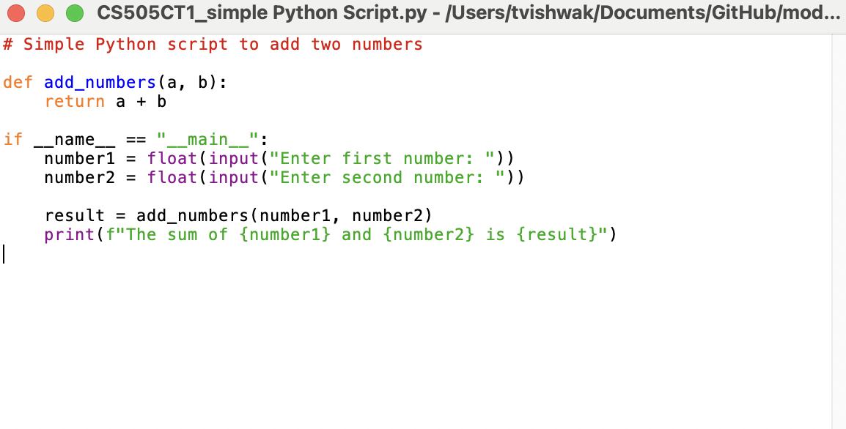

Execution -

